- Materials and methods
  - Digital terrain model

Before starting the environmental hydrodynamic analyses of a given region, the first step is to develop the digital terrain model (DTM). This process involves defining the study domain, subdividing it into discrete elements, and incorporating topographic information, such as depth and roughness data. The bathymetric data used in this study were obtained from the Municipal Government of Niterói (MGN), along with information on the morphological characteristics of the lagoons and time series of water level variations.
Depth data for the marine region were obtained from the nautical charts of the Brazilian Navy’s Hydrography and Navigation Directorate (DHN). Specifically, data were extracted from Nautical Chart No. 1501 (Guanabara Bay) and Nautical Chart No. 1511 (Barra do Rio de Janeiro), both produced and updated by the DHN. The bathymetric contours are referenced to the Chart Datum (Nível de Redução, NR) of Nautical Chart No. 1511 (Figure 3). The biquadratic isoparametric finite elements mesh applied for discretization of the studied region consisted of 1,378 elements, of which 1,301 were quadrilateral and 77 were triangular, with a total of 6,079 computational nodes.
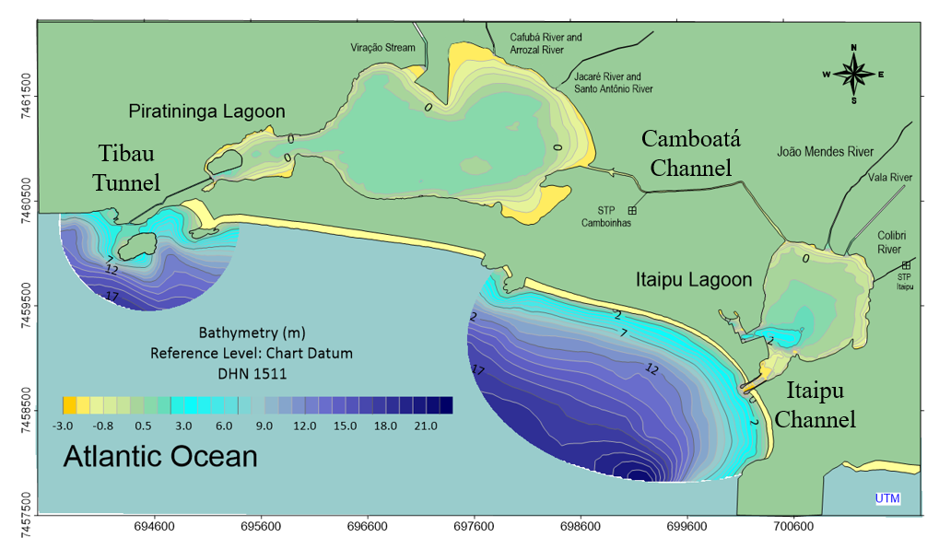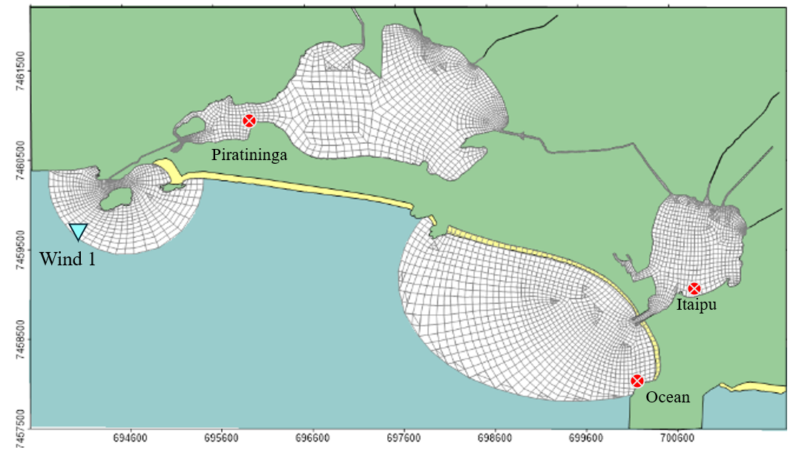
Figure 3 - Bathymetry used for modeling in the region of interest (on the top) and map of the lagoons with the mesh overlaid on the domain region (on the button). Points where water level measurements were taken are shown in red, and the wind measurement station is shown in blue.

Hydrodynamic model

For the analysis conducted in this study, which refers to a shallow lagoon system, the 2DH module of SisBaHiA® was applied, in which depth-averaged current velocities are computed. The governing equations of the 2DH hydrodynamic model are presented below. At each time-step, the 2DH hydrodynamic model computes the vertically averaged velocity components, $U(x,y,t)$ in the x-direction and $V(x,y,t)$ in the y-direction, as well as the free surface elevation $ζ(x,y,t)$. However, to determine these three unknowns, at least three equations are required: the vertically integrated momentum equations in the x and y directions—considering the shallow-water approximation—and the vertically integrated continuity equation for an incompressible homogeneous flow.
Equation (1) represents the 2DH momentum equation for a vertically integrated flow in the x-direction:
$$\frac{∂U}{∂t}+U\frac{∂U}{∂x}+V\frac{∂U}{∂y}=-g\frac{∂ζ}{∂x}+\frac{1}{ρ_{0}(ζ+h)}\left\{\frac{∂\left[\left(ζ+h\right){\hat{τ}}_{xx} \right]}{∂x}+\frac{∂\left[\left(ζ+h\right){\hat{τ}}_{yx} \right]}{∂y}\right\}+\frac{1}{ρ_{0}\left(ζ+h\right)}\left(τ_{x}^{S}-τ_{x}^{B}{-τ}_{x}^{E}\right)+2ΩsenΦV-\frac{U}{(ζ+h)}Σq$$
(1)
Equation (2) represents the 2DH momentum equation for a vertically integrated flow in the y-direction:
$$\frac{∂V}{∂t}+U\frac{∂V}{∂x}+V\frac{∂V}{∂y}=-g\frac{∂ζ}{∂y}+\frac{1}{ρ_{0}(ζ+h)}\left\{\frac{∂\left[\left(ζ+h\right){\hat{τ}}_{xy} \right]}{∂x}+\frac{∂\left[\left(ζ+h\right){\hat{τ}}_{yy} \right]}{∂y}\right\}+\frac{1}{ρ_{0}\left(ζ+h\right)}\left(τ_{y}^{S}-τ_{y}^{B}{-τ}_{y}^{E}\right)-2ΩsenΦU-\frac{V}{(ζ+h)}Σq$$

(2)
Similar terms in the momentum equation in the y-direction evidently have the same meaning as those in the x-direction equation.
Equation (3) is the3 vertically integrated continuity equation:
$$\frac{∂(ζ+h)}{∂t}+\frac{∂(ζ+h)}{∂x}+\frac{∂(ζ+h)}{∂y}= ∑q$$
(3)
In Equations (1), (2) e (3), the following variables are defined; $z=ζ(x,y,t)$ and h are the free surface elevation and bathymetry, respectively, referenced to the mean low water spring tide level; g is the gravitational acceleration; $ρ_{0}$ is the water density, assumed as constant; ${\hat{τ}}_{xx}, {\hat{τ}}_{xy} e {\hat{τ}}_{yy}$ are the turbulent shear stresses;$τ_{x}^{S}, τ_{x}^{B}{, τ}_{x}^{E}​$ are the shear stresses at the free surface, at the bottom, and due to the effect of structures inserted into the flow field, respectively, and Σq represents the fluxes of precipitation ($q_{P}$), evaporation ($q_{E}$) and infiltration ($q_{I}$) per unit area.

Eulerian Model for Advective-Diffusive Transport

Equation 8 presents the general formulation of the advection- diffusion transport equation for scalars in shallow water bodies, in which C is the concentration of the substance of interest, C_{ia} is the concentration of this given substance in the afluxes q_{P}, q_{E} and q_{I}, which are prescribed fluxes values per unit area, e.g. [m³/s/m²], corresponding to precipitation, evaporation and infiltration, respectively, H is the water column height, R represents the kinetic reactions of production and consumption of a given scalar and the T terms denote turbulent diffusion coefficients.

$\frac{∂C}{∂t}+U\frac{∂C}{∂x}+V\frac{∂C}{∂y}= \frac{1}{H}\frac{∂}{∂x}\left(T_{xx}\frac{∂C}{∂x}+T_{xy}\frac{∂C}{∂y}+T_{xt}\frac{∂C}{∂t}\right)+\frac{1}{H}\frac{∂}{∂y}\left(T_{yx}\frac{∂C}{∂x}+T_{yy}\frac{∂C}{∂y}+T_{yt}\frac{∂C}{∂t}\right)-\frac{C}{H}\left(q_{p}-q_{E}\right)+\frac{{(C}_{Ia}-C)}{H}q_{Ia}+\sum{R}$ (4)

    - Renewal rate model

For this type of analysis, a generic fictitious substance was considered, treated as passive and conservative. Unlike other water quality parameters, this substance undergoes only advective and diffusive transport, since these are the only processes occurring during water volume exchange. Using an Eulerian approach, which allows the analysis of water parcels at different locations over time, the water flow passes through a control volume treated as an observation point. Therefore, to analyze the characteristic water renewal time, the water initially present within the domain at the beginning of the simulation is assigned a reference value of 0%, while the water entering the domain through open boundaries or other inflows, such as rivers, is assigned a reference value of 100%. As the so-called “new” water (100%) mixes with the initial water (0%), intermediate values are computed, indicating the percentage of mixing at a given moment.
Water renewal rates are hydraulic characteristic times associated with the renewal concept, representing the time required, relative to the initial condition, for a water parcel to reach a specific value. That is, once the model has run for a sufficient period, all the original water should be replaced by new water. In this analysis, the models were run to achieve full system renewal, and to ensure this condition, two simulation cycles were performed, totaling a period of 70 days.

    - Water age model

For this study, the analysis of water age allows one to define the average time in which water remains within the predefined domain over time. According to Rosman (2025), this time is estimated based on the decay of a passive age-tracer substance present in the water.
To determine the decay time, a first-order kinetic decay reaction of the age-tracer substance is required, with a constant rate k > 0, and without any other mass loss or gain effects.
To conceptualize the calculation, consider a uniform volume of well-mixed water throughout the domain, with an initial concentration C₀ of the age-tracer substance. Assuming a first-order decay kinetics, the temporal variation of the age-tracer substance concentration C(t) is given by Equation (9):
$$\frac{∂C}{∂t}=-kC$$
(5)

Which’s analytical solution leads to (10):
$$C\left(t\right)= C_{0}exp⁡(-kt)$$
(6)
And therefore
$$t= \frac{-\ln\left(\frac{C}{C_{0}}\right)}{k}$$
(7)
Once the initial concentration C₀ and the subsequent concentration C(t) are known, the decay time between these two concentration values defines the water age at the time corresponding to the recorded concentration C(t).
The variable k is the inverse of time, and its magnitude is more intuitively understood through equivalent time scales, such as the well-known half-life time, denoted as T₅₀, which represents the time required for a given concentration to be reduced to 50% of its initial value.
When considering a water body with C = C₀, inflows at multiple points and times, and outflows with different decomposition periods, it becomes evident that the concentration will be a function of both time and space. Therefore, the water age (Equation 12) will also be a function that varies spatially and temporally.
$$I_{A}(x, y, t)=\frac{-ln\frac{C(x,y,t)}{C_{0}}}{k}$$
(8)
For this study, an initial condition of C = 1 was assigned throughout the mesh domain. During the simulation period, new water enters the domain through open boundary limits or inflows. As simulation time progresses, the water within the domain becomes older and mixes with the incoming new water.
Thus, areas with higher renewal dynamics remain younger, while regions with lower water renewal reach higher ages as the simulation advances. In the model, both rivers and the adjacent ocean introduce new water into the lagoons. In practice, however, this incoming water is not necessarily clean.

Tidal and wind conditions

Figure 4 shows the water level time series imposed as open boundary condition for the hydrodynamic models, which consists of data measured during a field campaign commissioned by the MGN in the study area, covering a period of 35 days, starting on 09/22/2018. Figure 3 shows the measurement locations for the water levels considered.
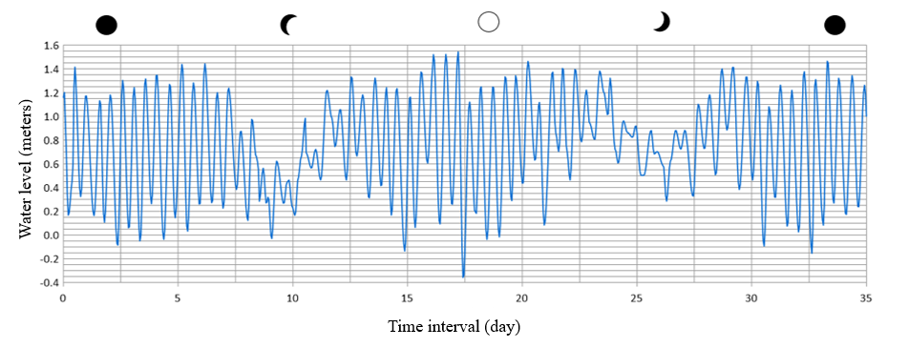Figure 4 - Tidal variations observed during the study period, imposed on the model as open boundary condition. Level Reference: Chart Datum Reduction Level 1511 DHN.

The wind pattern observed near the lagoon system shows a predominant direction in the first quadrant, in addition to low wind speeds. The wind rose corresponds to the 35 days simulated period, starting on 22 September 2018 (Figure 5).
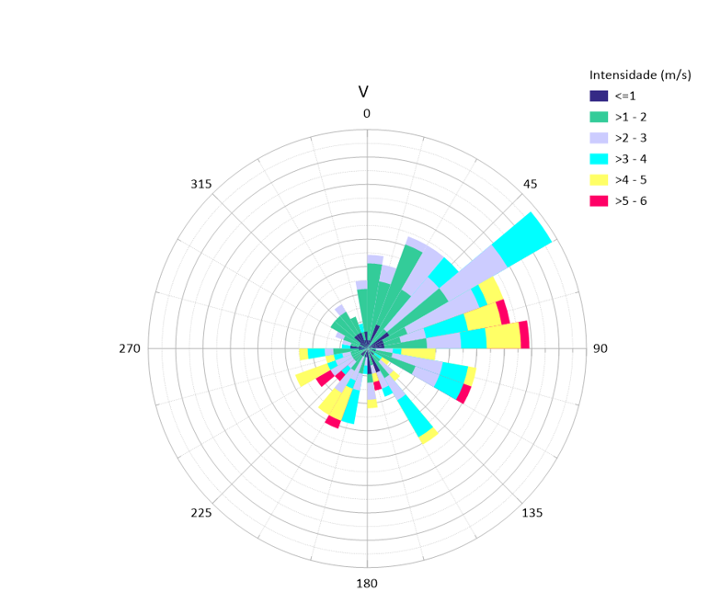
Speed (m/s)
Wind 1
Figure 5 - The percentage distribution of wind occurrences.
The wind data applied in this study were obtained from atmospheric reanalysis products provided by ERA5, produced by the European Centre for Medium-Range Weather Forecasts (ECMWF), and were employed to supply wind information required for the hydrodynamic models.
For the present work, a time series of wind speed and direction was extracted from a grid point near the Piratininga-Itaipu lagoon system region (Figure 3). These data were applied to the model to represent local wind conditions, directly influencing the hydrodynamic circulation and mixing processes within the studied system.
PMN conducted a monitoring campaign of water level variations at three locations within the study area (Figure 3). The first measurement point was located in the marine portion near Itaipu Beach, on the rocky shoreline known as Morro das Andorinhas. The second point was situated inside the Itaipu Lagoon, while the third measurement point was established within the Piratininga Lagoon. The data obtained during the campaign were made available for this study and used in distinct ways. The records collected in the marine portion near Itaipu Beach were employed as tidal variation input for the hydrodynamic model, as previously mentioned. Meanwhile, the data measured in the Itaipu and Piratininga lagoons were essential for the model calibration and validation processes, ensuring its accuracy and representativeness in the simulations performed for the lagoon system.
    - River and WTP inflow rates
and Table 2 presents the discharge data in regard of the rivers flowing into the lagoons and of the wastewater treatment plants, which were obtained from HYDROSCIENCE (2018). These data refer to the average flow rates calculated for the year 2018 and were used as boundary conditions for the hydrodynamic models. The location of these discharges is presented in Figure 3.
Table 1 - Inflows to the lagoons
River | Discharge (m³/s)
Viração Stream | 0.14
Cafubá and Arrozal Rivers | 0.26
Santo Antônio and Jacaré Rivers | 0.46
João Mendes River |  | 0.78
Vala River |  | 0.16
Colibris River |  | 0.08

Table 2 - Wastewater Treatment Plants Outflows
Wastewater Treatment Plants | Discharge (m³/s)
WTP Camboinhas | 0.078
WTP Itaipu | 0.075

